**Extension: Isosceles Triangle & Overlapping Triangle Proofs**

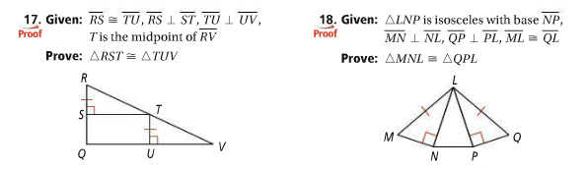

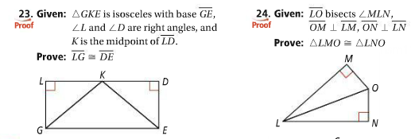



Screen%20Shot%202016-11-02%20at%2010.02.16%20PM.png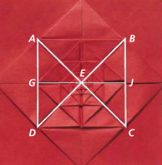

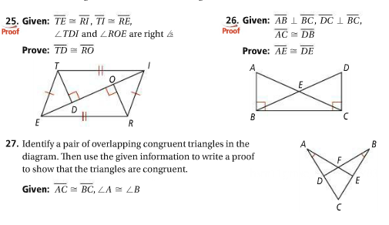

**3.12 Overlapping Triangles**

*You will receive a 7/10 for completing the first page*

*You will receive an 8/10 for completing the second page as well*

*You will receive a 9/10 for completing the third page*

*You will receive a 10/10 for completing the last page*



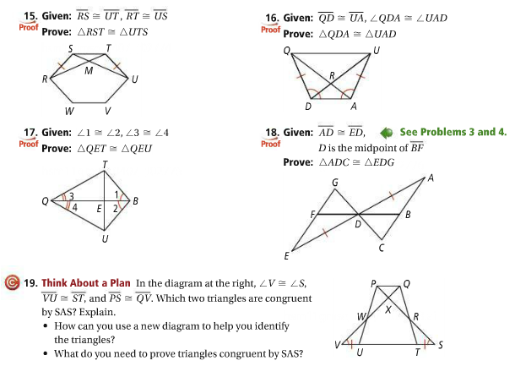









20.   
